Task 1
public class BuilderPatternDemo {

// Product interface
interface Gadget {
void showSpecs();
}

// Concrete product
static class Mobile implements Gadget {
private int storage;
private int memory;

public void setStorage(int storage) {
this.storage = storage;
}

public void setMemory(int memory) {
this.memory = memory;
}

@Override
public void showSpecs() {
System.out.println("Mobile Specifications:");
System.out.println("Storage: " + storage + " GB");
System.out.println("Memory: " + memory + " GB");
}
}

// Builder interface
interface GadgetBuilder {
GadgetBuilder buildStorage(int storage);
GadgetBuilder buildMemory(int memory);
Gadget build();
}

// Concrete builder
static class MobileGadgetBuilder implements GadgetBuilder {
private Mobile mobile;

public MobileGadgetBuilder() {
this.mobile = new Mobile();
}

@Override
public GadgetBuilder buildStorage(int storage) {
mobile.setStorage(storage);
return this;
}

@Override
public GadgetBuilder buildMemory(int memory) {
mobile.setMemory(memory);
return this;
}

@Override
public Gadget build() {
return mobile;
}
}

// Director
static class GadgetDirector {
private GadgetBuilder gadgetBuilder;

public GadgetDirector(GadgetBuilder gadgetBuilder) {
this.gadgetBuilder = gadgetBuilder;
}

public Gadget constructGadget() {
return gadgetBuilder
.buildStorage(512)
.buildMemory(16)
.build();
}
}

// Main method (Client code)
public static void main(String[] args) {
GadgetBuilder builder = new MobileGadgetBuilder();
GadgetDirector director = new GadgetDirector(builder);

Gadget mobile = director.constructGadget();
mobile.showSpecs();
}
}
output:- Mobile Specifications:
Storage: 512 GB
Memory: 16 GB

Task 2
// Iphone interface
public interface Iphone {
void onCharge();
void offCharge();
}

// Charger interface
interface Charger {
void charge();
void removeCharge();
}

// Concrete class implementing Charger
class Iphone16Charger implements Charger {
Iphone16Charger() {
System.out.println("Iphone16Charger is ready.");
}

@Override
public void charge() {
System.out.println("I am charging Iphone 16");
}

@Override
public void removeCharge() {
System.out.println("Stopped charging Iphone 16");
}
}

// Adapter class implementing Charger and adapting Iphone16Charger
class Iphone16Adapter implements Charger {
Iphone16Charger iphone16Charger;

Iphone16Adapter() {
iphone16Charger = new Iphone16Charger();
}

@Override
public void charge() {
iphone16Charger.charge();
}

@Override
public void removeCharge() {
iphone16Charger.removeCharge();
}
}

// Iphone16 class implementing Iphone and using the adapter
class Iphone16 implements Iphone {
Charger iphone16Adapter;

Iphone16(Charger iphone16Adapter) {
this.iphone16Adapter = iphone16Adapter;
}

@Override
public void onCharge() {
iphone16Adapter.charge();
}

@Override
public void offCharge() {
iphone16Adapter.removeCharge();
}
}

// Client class to test the Adapter pattern
public class ClientAdapterDpMain {
public static void main(String[] args) {
Iphone iphoneObj = new Iphone16(new Iphone16Adapter());
iphoneObj.onCharge();
iphoneObj.offCharge();
}
}

Output:- Iphone16Charger is ready.
I am charging Iphone 16
Stopped charging Iphone 16
Task 3
public class FacadePatternDemo {

// Subsystem class
static class FdService {
public void getFdServiceDetails(String accountNo) {
System.out.println("Fetching FD details for account: " + accountNo);
}
}

// Facade class
static class BankFacade {
private FdService fdService;

// Constructor
public BankFacade() {
this.fdService = new FdService();
}

// Facade method to access FD service
public void getFdServiceDetails(String accountNo) {
fdService.getFdServiceDetails(accountNo);
}
}

// Client code (main method)
public static void main(String[] args) {
BankFacade bank = new BankFacade();
bank.getFdServiceDetails("ACC1234567890");
}
}
output:- Fetching FD details for account: ACC1234567890

Task 4
import java.util.HashMap;

// Flyweight interface
interface Shape {
void draw(int x, int y, int radius);
}

// Concrete Flyweight class
class Circle implements Shape {
private String color; // intrinsic state

public Circle(String color) {
this.color = color;
}

@Override
public void draw(int x, int y, int radius) {
System.out.println("Drawing Circle [Color: " + color +
", X: " + x + ", Y: " + y + ", Radius: " + radius + "]");
}
}

// Flyweight Factory
class ShapeFactory {
private static final HashMap<String, Shape> circleMap = new HashMap<>();

public static Shape getCircle(String color) {
Circle circle = (Circle) circleMap.get(color);

if (circle == null) {
circle = new Circle(color);
circleMap.put(color, circle);
System.out.println("Creating circle of color: " + color);
}
return circle;
}
}

// Client Code
public class FlyweightPatternDemo {
private static final String[] colors = { "Red", "Green", "Blue", "White", "Black" };

public static void main(String[] args) {
for (int i = 0; i < 10; ++i) {
Shape circle = ShapeFactory.getCircle(getRandomColor());
int x = getRandomX();
int y = getRandomY();
int radius = 100;
circle.draw(x, y, radius);
}
}

private static String getRandomColor() {
return colors[(int)(Math.random() * colors.length)];
}

private static int getRandomX() {
return (int)(Math.random() * 100);
}

private static int getRandomY() {
return (int)(Math.random() * 100);
}
}
output:- Creating circle of color: Red
Drawing Circle [Color: Red, X: 38, Y: 92, Radius: 100]
Creating circle of color: Green
Drawing Circle [Color: Green, X: 12, Y: 67, Radius: 100]
Drawing Circle [Color: Red, X: 91, Y: 4, Radius: 100]
Task 5
// Bridge Pattern Demo
public class BridgePatternDemo {

// Implementor interface
interface Color {
String fill();
}

// Concrete Implementors
static class RedColor implements Color {
@Override
public String fill() {
return "Red";
}
}

static class BlueColor implements Color {
@Override
public String fill() {
return "Blue";
}
}

// Abstraction
abstract static class Shape {
protected Color color; // Bridge to implementor

public Shape(Color color) {
this.color = color;
}

abstract void draw();
}

// Refined Abstraction
static class Circle extends Shape {
public Circle(Color color) {
super(color);
}

@Override
public void draw() {
System.out.println("Drawing Circle filled with color: " + color.fill());
}
}

static class Square extends Shape {
public Square(Color color) {
super(color);
}

@Override
public void draw() {
System.out.println("Drawing Square filled with color: " + color.fill());
}
}

// Client code
public static void main(String[] args) {
Shape redCircle = new Circle(new RedColor());
Shape blueSquare = new Square(new BlueColor());

redCircle.draw(); // Output: Drawing Circle filled with color: Red
blueSquare.draw(); // Output: Drawing Square filled with color: Blue
}
}
Output:- Drawing Circle filled with color: Red
Drawing Square filled with color: Blue

Task 6
Create a class diagram in uml..
@startuml
class Calculator {
+ calculateSum(in num1: int, in num2: int, out result: int)
+ updateStatus(inout status: String)
}
@enduml

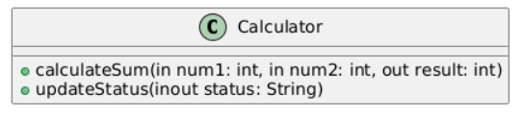
Task 7
What are the commonly used visibility Notations in class diagrams?
Answer:- In UML class diagrams, visibility notations define how class members (attributes and methods) are accessed. These notations specify the access level of a field or method.

✅ Commonly Used Visibility Notations:
Symbol | Visibility | Description
+ | Public | Accessible from anywhere (any class)
- | Private | Accessible only within the class
# | Protected | Accessible within the class and subclasses
~ | Package (default) | Accessible by classes in the same package/module

🧠 Example UML Class with Visibility Notations:
@startuml

class Example {
- id: int // private attribute
+ name: String // public attribute
# calculate(): double // protected method
~ logData(): void // package-private method
}

@enduml

✅ Summary:
Notation | Keyword Equivalent in Java
+ | public
- | private
# | protected
~ | (default access)

Task 8
What do you know about Parameter Directionality?
Answer:- ✅ Parameter Directionality in UML
Parameter directionality describes how data flows into and out of operations (methods) in a UML class diagram. It is used to clarify whether a parameter is:
- An input
- An output
- Or both
This concept is helpful when modeling systems, especially in interface design, method documentation, and collaborative development.

🎯 Common Directional Keywords
Direction | Keyword | Meaning
Input | in | Data is passed into the operation only.
Output | out | Data is passed out of the operation (the method sets it).
Input/Output | inout | Data is passed in, possibly modified, and returned.
Return | (return type) | Returned from the method (not a parameter, but part of signature).

🧠 Example (UML Method Signature)
class Calculator {
+ calculateSum(in num1: int, in num2: int, out result: int)
+ updateStatus(inout status: String)
}
- calculateSum: takes two numbers (in), calculates sum, stores it in result (out)
- updateStatus: modifies the passed-in status string (inout)

🔁 Usage in Programming Languages
Language | Native Support for in, out, inout
Java | ❌ No direct support (use return or mutable objects)
C++ | ✅ Use pointers or references
C# | ✅ Has ref, out, and in keywords
Python | ❌ Pass-by-object-reference can simulate inout
Swift | ✅ Has inout keyword

✅ Summary
Parameter directionality:
- Improves method clarity in UML diagrams.
- Defines how data flows between the caller and the operation.
- Is especially important in interface design, distributed systems, and multi-language modeling.

Task 9
Class Diagram Relationships
✅ UML Class Diagram Relationships
In UML class diagrams, relationships between classes help describe how classes are connected and interact with each other. Understanding these relationships is essential for designing object-oriented systems.

📘 Common UML Class Diagram Relationships
Relationship | Symbol | Meaning | Example
Association | → or line | "Uses" or "has a" relationship between two classes | A Customer places an Order
Multiplicity | 1, 0..1, * | How many objects are involved | A Company has * Employees
Aggregation | ◇ | Whole-part (weak ownership) | A Team has Players (players can exist independently)
Composition | ◆ (filled diamond) | Whole-part (strong ownership) | A House has Rooms (rooms cannot exist without the house)
Inheritance / Generalization | ▲ (triangle) | "Is-a" relationship | A Dog is a Animal
Realization (Interface implementation) | ▭▶ (dashed triangle) | Class implements an interface | Bird implements Flyable
Dependency | ──▷ (dashed line) | Temporary use of a class | ReportGenerator uses Logger
Association Class | Class connected to a relationship | Used when the association has attributes | A Membership between User and Club has role

🧠 Example in PlantUML
@startuml

class Customer
class Order
class Product

Customer "1" --> "*" Order : places
Order "1" --> "*" Product : contains

class Team
class Player
Team o-- "11" Player : has

class House
class Room
House *-- Room : composed of

class Animal
class Dog
Animal <|-- Dog

interface Flyable
class Bird
Bird ..|> Flyable

class Logger
class ReportGenerator
ReportGenerator ..> Logger : logs with

@enduml

✅ Visual Symbols Summary
Relationship | Symbol in Diagram
Association | Solid line with arrow or none
Aggregation | Open diamond o--
Composition | Filled diamond *--
Inheritance | Triangle arrow `<
Realization | Dashed triangle `..
Dependency | Dashed line with arrow ..>
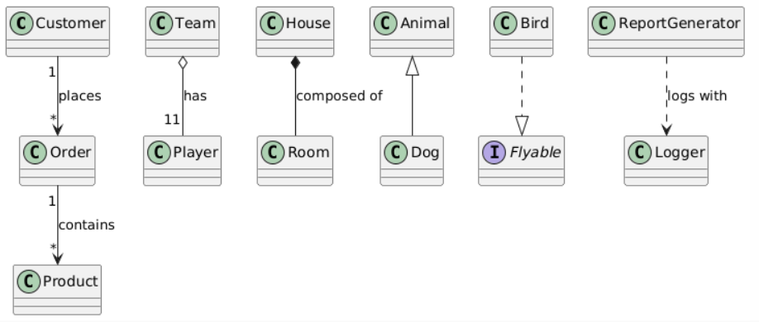

Task 10
represent a Package diagram

Sure! Here's how you can represent a Package Diagram in UML (Unified Modeling Language) using both a text-based description and a PlantUML example, which is widely used for generating UML diagrams.

✅ What is a Package Diagram?
A package diagram in UML is used to organize and group related classes or elements into packages, making complex systems more manageable. It shows how packages depend on or relate to each other.

📦 Simple UML Package Diagram Structure
+-----------------+ +------------------+
| Package A |-------->| Package B |
|-----------------| |------------------|
| ClassA1 | | ClassB1 |
| ClassA2 | | ClassB2 |
+-----------------+ +------------------+
|
v
+-----------------+
| Package C |
|-----------------|
| ClassC1 |
+-----------------+
- Solid arrow → indicates dependency between packages.

🌱 PlantUML Example of a Package Diagram
@startuml

package "User Module" {
class User
class Profile
}

package "Order Module" {
class Order
class Invoice
}

package "Product Module" {
class Product
class Category
}

' Dependencies
User --> Order : places
Order --> Product : contains
User --> Profile : has

@enduml

📌 Explanation:
- Packages: User Module, Order Module, and Product Module group related classes.
- Arrows: Show how one class depends on or communicates with others across packages.

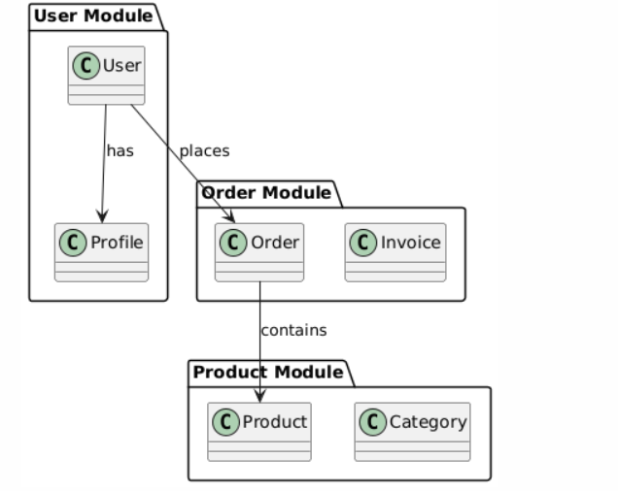

Task 11
what is state notation .. initial and final ?
Answer:- ✅ What is State Notation in UML?
State Notation is used in a UML State Machine Diagram to represent the different states an object can be in during its lifecycle and how it transitions between these states.

🔄 Key Elements of State Notation
1. State
- Represents a condition or situation in the life of an object.
- Notation: A rounded rectangle with the state name inside.
Example:
+-------------+
| Processing |
+-------------+

2. Initial State
- Represents the starting point of the state machine.
- Notation: A filled black circle (●)
- Only one per diagram.
Example:
● ----> Idle

3. Final State
- Represents the end of the object’s lifecycle or state process.
- Notation: A circle with a dot inside (◎)
- Can be zero or multiple depending on the diagram.
Example:
Shutdown ----> ◎

🧠 Example State Transition
● ----> Idle
Idle ----> Processing : start()
Processing ----> Completed : finish()
Completed ----> ◎

📘 Use Case Example
For an Order object:
- Initial State: ●
- States: New, Processing, Shipped, Delivered
- Final State: ◎

